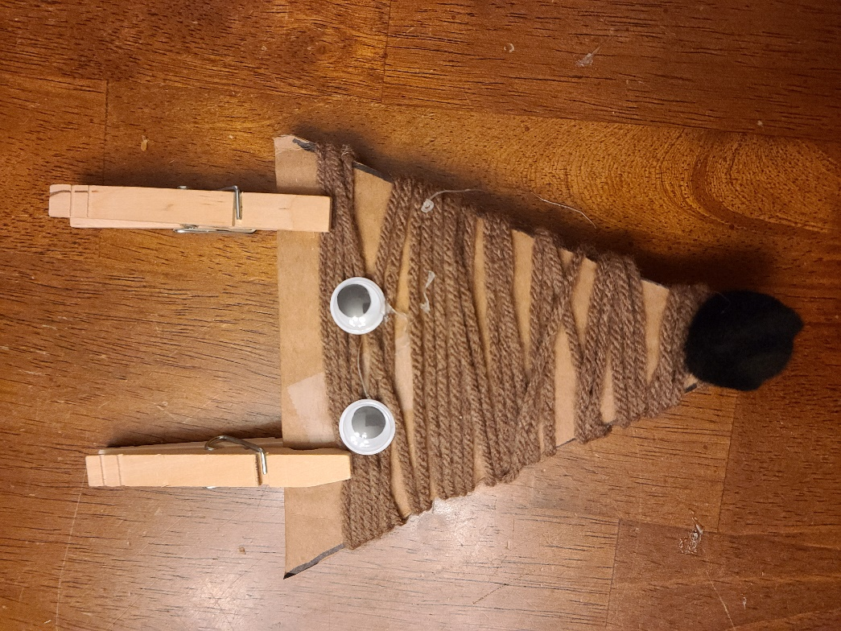
Deer Craft Supplies

1 cardboard triangle (about 4 inches)
Spool of brown yarn
2 wiggly eyes
1 black pompom
2 wooden clothespins
Craft glue
Safety scissor
Clear tape

