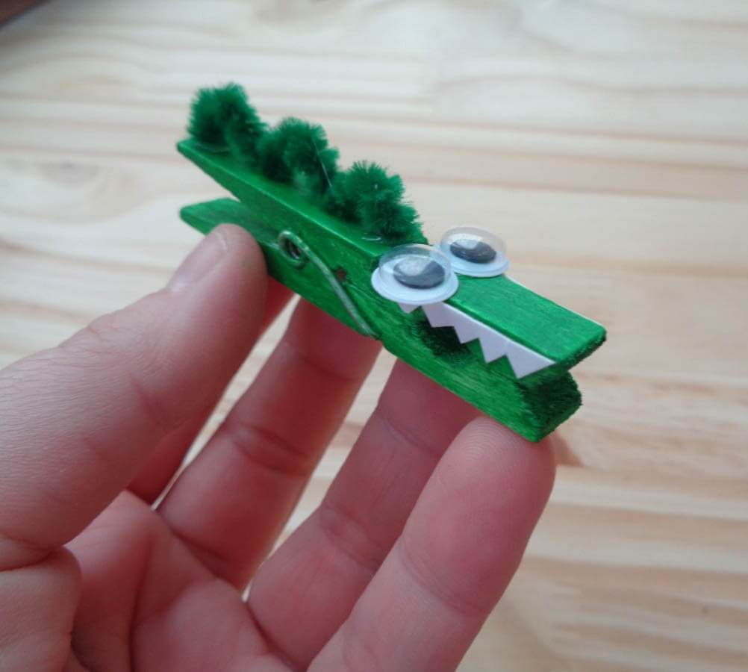

Clothespin Crocodile Craft Supplies

1 large clothespin
2 wiggle eyes
1 green pipecleaner
1 sheet white paper
1 green marker
Craft glue
Safety scissor

