10 Essential Ways to Protect Your Gut Microbiome
by Dr. Frank Lipman | Mar 15, 2021 | Featured, Health & Wellness
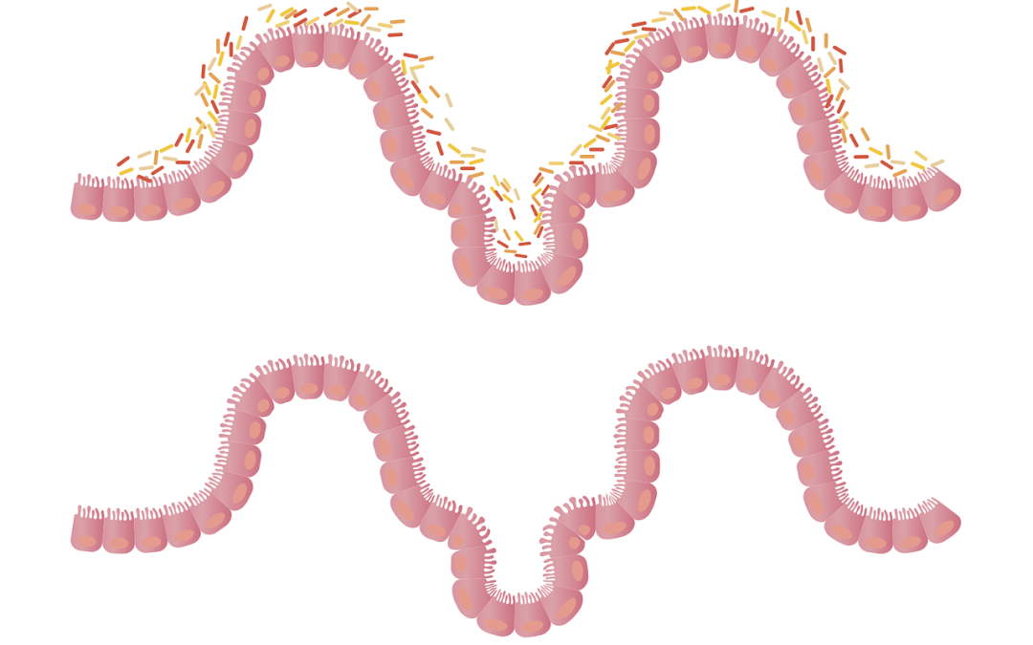
A happy, trouble-free gut is a key to a strong immune system and to keeping your entire body healthy, (especially when we’re (still) in the midst of a pandemic). A disruption in the microbiome, known as a dysbiosis, leads to inflammation in the gut, and if not addressed, leads to systemic inflammation and consequently to all sorts of chronic diseases. The stronger and more resilient your gut is – and the more harmoniously balanced the trillions of bacteria that live there — the better your heart, brain, immune system and just about every other part of your body will function. In short, the better you protect your gut from the stuff than can do it harm, the better it can protect you from the countless diseases that are capable of wrecking your quality of life. Sound like a plan?
What follows is my list of gut-busters – the things that can wreak havoc on the intestinal tract – and how to avoid them:

1) Steer clear of sugar and starches.
They both do a number on the gut which is one big reason most Americans develop at least one chronic disease in middle age. The problem is, sugar and starch (which breaks down into sugar in the bloodstream) decrease the number of beneficial bacteria in the gut while feeding the overgrowth of non-beneficial (aka ‘bad’) bacteria. The net result is microscopic leaks in the gut wall’s one-cell-thick lining. That allows partially digested food particles and toxins to slip into the bloodstream, triggering an immune system overreaction and inflammation throughout the body. One common consequence? Metabolic syndrome which puts you at much higher risk for heart disease, diabetes and obesity. That same inflammation is also associated with increased risk for arthritis, Alzheimer’s and many types of cancer. The unavoidable take-away: avoid (or strictly limit) the sugar and starch!

2) Go without Gluten.
Stop me if you’ve heard this one before but … gluten is bad news for many, many guts. And if you eat a Standard American Diet (SAD), you’re eating gluten – think wheat, barley and rye – multiple times a day. Cereal for breakfast, a sandwich for lunch, and pasta for dinner is, besides being low on nutrients, a recipe for a leaky gut and a hop-skip to inflammation and/or gastrointestinal complaints like gas, bloating and constipation. (The catch-all term is irritable bowel syndrome.) While there is a wide spectrum of reactions to gluten, from minimal annoyance to potentially life-threatening allergies and autoimmune disease, your best bet is to give it a wide berth. Less gluten means less irritation of the gut wall, less gut permeability, less inflammation and ultimately, less illness and disease risk for you in both the near and long term.

3) Ditch so-called ‘vegetable’ oils.
The oils you cook with, drizzle over your salad, and sauté your veggies in matter, and if you’re using super-processed crap oils made from stuff like corn, soy, cottonseed, safflower seed or rapeseed (aka canola oil), you’re barking up the wrong plant. These oils, despite their ‘health-washed’ reputations, can do far more harm than good, especially in the gut. Their high levels of omega-6 fatty acids make them highly susceptible to oxidation, both on the shelf and inside your body, an inflammation-promotor. All that excess omega-6 also tends to reduce the availability of inflammation-reducing omega-3s in your tissues. And the industrial chemicals that manufacturers use to process these oils are no health bargain either. What to drizzle instead? Minimally processed, truly health-supportive oils, like extra virgin, cold-pressed olive, coconut and avocado.

4) Processed foods – and all their additives – you really can do without.
There is no shortage of reasons why you should purge your life and pantry of processed, ultra-processed and additive-doused foods. But let’s start with this one – they all disrupt the health of your gut! Convenient as it may be to fill your cart at Trader Joe’s with ‘time-saving’ pre-made, processed frozen meals and shortcuts, they’re loaded with food additives of questionable or scary provenance and virtually devoid of fiber and/or nutritional value – the very definition of empty calories. Worse yet, while we have some idea about the gut-busting, inflammatory effects of extremely common food additives like carrageenan, polysorbate-80, maltodextrin and so on, most of the additives, preservatives and chemicals baked into processed foods react and interact in our systems over time in ways that we can’t even guess at. Well, I can guess. It’s nothing good! By contrast, when you opt for fresh, whole foods, from the farmers’ market or organic aisle, you’ll have none of those concerns – and no gut demolition either.

5) Keep toxins and pesticides – and especially glyphosate – out of your gut!
Shifting to toxin-free foods, greener cleaners and cookware and far away from plastics is one of the most important things you can do for your gut. Less exposure to toxins equals a healthier gut. Take, for example, the particularly frightening glyphosate (aka Round-Up herbicide). Glyphosate actually messes with your gut and the bacteria that live there by behaving like the powerful antibiotic it is, wiping out beneficial bacteria and promoting the growth of the bad. Or BPAs, which turn up in plastic containers, water bottles, toys and on register receipts. They leech toxins which promote bad bacterial overgrowth and, ultimately, leaky gut. Hardly the ideal scenario for cultivating a healthy belly! But, by removing as many of these toxins, pesticides and chemicals as you can, not only do you keep your microbiome healthy and your gut wall strong, you’ll avoid these dangerous substances which are thought to be responsible for a host of behavioral, neurological, autoimmune and respiratory problems. As with the processed foods additives, a lot of the long-term health effects of these chemicals, and their effects in combination, have not yet been pinned down. Feel like rolling the dice? Didn’t think so.

6) Gut health doesn’t come in a bottle (of booze).
An entirely avoidable toxin is one that many people have leaned on a bit too heavily this past year – and that’s alcohol. Understandable, for sure, but I strongly advise you to start tapering off ASAP. Alcohol is a toxin that harms the liver, kills brain cells, messes with sleep and, you guessed it, alters the microbiome. Though your gut bacteria do help metabolize the alcohol you drink, too much ‘liquid courage’ can inhibit digestive enzyme production, which not only makes it harder to properly digest and absorb nutrients from food but also inflames the gut. It’s a simple equation: the less you drink, the less risk of bacterial overgrowth and dysbiosis, and the stronger, better balanced and healthier your gut will be.

7) Drugs take a bite out of your gut health.
One big gut-destabilizer you may not be aware of are medications. Be they over-the-counter or prescription, many everyday meds can throw off your bacterial balance and encourage the bad guys to thrive. Among the top offenders: non-steroidal anti-inflammatory drugs (NSAIDs), proton pump inhibitors (or PPIs), oral contraceptives and antidepressants like Prozac. And those antibiotics you pop like candy? In a word, stop! Antibiotics kill off both beneficial and non-beneficial bacteria, leaving you potentially even more vulnerable to the next infection that crosses your path – not where you want to be in a pandemic! For some people in some situations, drugs may be deemed medically necessary. But I urge you to minimize their use – particularly PPIs – to help keep your microbiome in top shape. If they’re unavoidable, work with your doc to keep the dosages to an absolute minimum and follow my prescription for repairing a troubled gut.

8) Bugs undermine your gut too!
Not surprisingly, illness-making bugs, be they bacterial, viral, fungal or parasitic, also alter the bacterial balance in your gut, weakening your immune defenses and leaving you more vulnerable to disease. A case in point: if you’ve ever had a bout of food poisoning, you know it may take quite a while to feel ‘normal’ again. For some people, a particularly bad bout can even alter the microbiome so much so that longer lasting problems like irritable bowel syndrome can result. And when it comes to COVID-19, a recent study by the Department of Microbiology at The Chinese University of Hong Kong found that patients with the infection had higher numbers of bacteria associated with inflammatory bowel disease and lower numbers of other potentially protective bacteria species, compared with those without the virus. That only underscores the importance of keeping the gut healthy and strong, before, during and after the pandemic.

9) Your gut needs good sleep – and less stress — to thrive.
Ever notice how when you’re short on sleep and/or stressed out, sniffles, colds and flu are almost sure to follow? That’s your belly bacteria telling you it’s time to pay attention to how you’re treating them. Shortchanging yourself of sleep disrupts your natural circadian rhythms, leading to changes in gut permeability, and reductions in beneficial bacteria. Poor sleep and chronic stress can also negatively impact the diversity of the bacteria in your gut, as well as the other microorganisms – including viruses, protozoa and fungi – that live there, while also triggering inflammation. That reduced diversity means increased susceptibility to pathogens that can make you very ill. To fight back, and stay well, make good rest, relaxation and stress reduction a priority that will benefit you head-to-toe – and gut.

10) Too much exercise or too little movement is bad news for the belly.
As with most things, balance is key, and when it comes to maintaining a balanced microbiome, movement, is terrific for increasing the numbers of good bacteria in your gut, modifying gut microbiota with positive health effects, while also helping to keep inflammation at bay. Keep in mind though that too much of a good thing – i.e. movement – is not better for your belly either. Over-doing it with intense physical exercise according to a recent study, was shown to have a negative impact, causing changes in gut bacteria. On the flip side, remaining sedentary will not do your microbiome any favors either, with sedentary lifestyles being associated with a increased risk for inflammatory bowel disease, a disturbed microbiome, and a significantly less diverse and robust microbiome when compared to those with more active lifestyles.
To learn more on how to improve your gut health in order, check out my post How to Heal Leaky Gut and Repair the Gut Lining.

